|  |  |
| --- | --- |
| **Name of volunteer** |  |
| **Name of Referee** |  |
| **How many years have you known the volunteer** |  |
| **Date of Reference** |  |

**About Ease Neurocare Foundation Trust**

Ease Neurocare is an organisation established in 2021. Ease supports family carers or parents who care for SEND – Special education need and disability children/young people/adults. Our areas of expertise include autism, associated syndrome, learning disability and childhood & adult dementia. We support these families and their wards through assessment, interventions and clinical referrals in other to move them towards achieving their life skill goals and attaining independence.

**Advise for Referees**

This advice is intended for all referees, including tutors, employers, careers advisers and other suitable persons.

Ease Neurocare Foundation Trust uses references to assist in the process of admitting volunteers when assessing an applicant's suitability for voluntary service. We are looking for the following key facts about a prospective volunteer:

● Their skills for care and compassion for those in need of disability support.

● Their potential to succeed as volunteers.

● Why the area they have chosen to volunteer in is suited to them

● Any personal qualities such as relevant skills, aptitude and enthusiasm

● What they can bring to the foundation trust, such as extra-curricular activities and interests.

**Below is a sample for a character reference note:**

**Go to page 3 & complete your reference.**

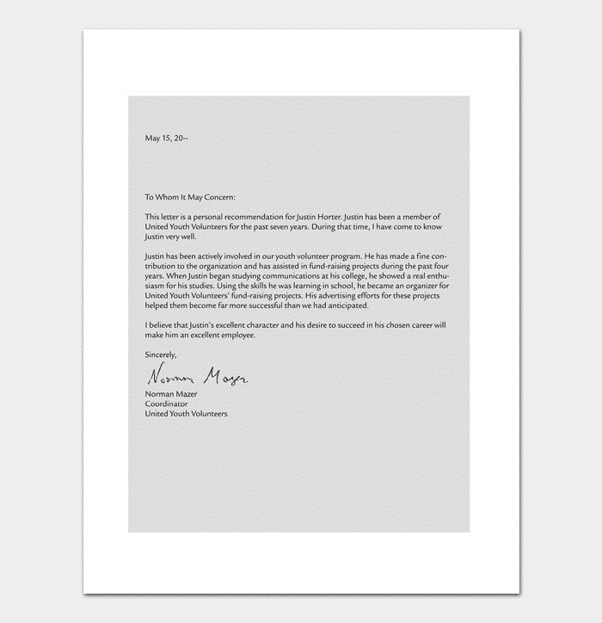

**Go to page 3 & complete your reference.**

**Your Reference Note and Signature (Your name at the end of your note is accepted as an e-signature.**

**Official Stamp if required**